**Daily Scrum or Standup Meeting**

Team name: ________Group 2_________________

Scrum Master: ______Emily_________________

Date:__________11/11_____________________

| **Team Member** | **What did you do since the last scrum?** | **What do you plan to do before the next scrum?** | **What obstacles do you have?** |
| --- | --- | --- | --- |
| Emily | Displayed paid orders | Customer pays for order, update status after payment and after cashier submission | Other classes |
| Maris | Small progress on drink customizing | Finish logic for drink customization and adding it to an order | Time |
| Karl | Styling error with extra margin | Fix the error | I don’t know how to solve it, but i’ll figure it out |
|  |  |  |  |
|  |  |  |  |

# Burndown

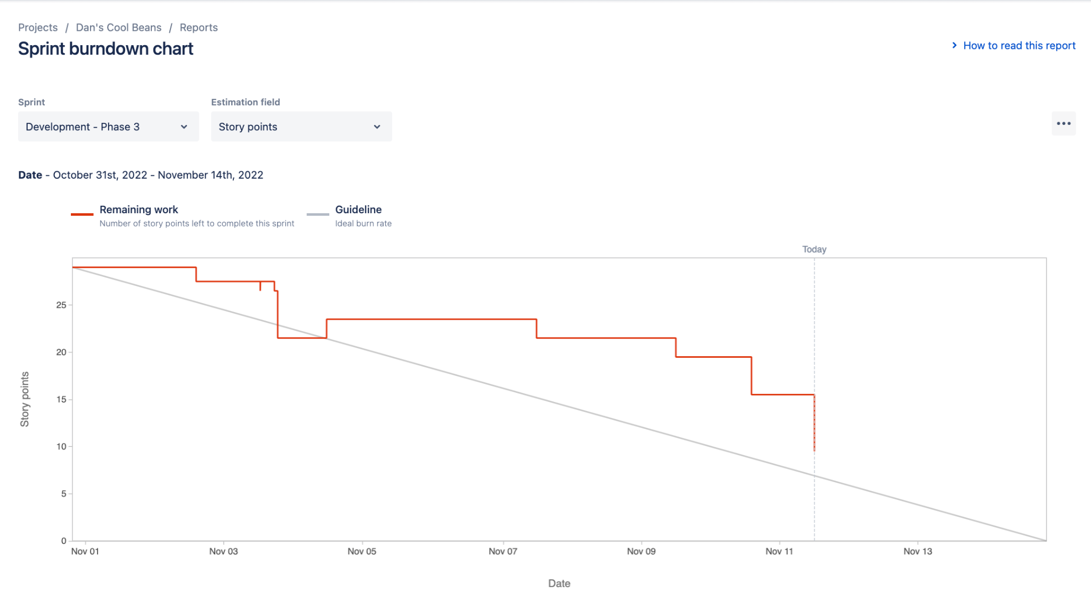

# Screenshot of you project board

